Samarth Rural Educational Institute’s
Samarth College of Computer Science, Belhe
Academic Year 2026-2027(SEM-V)
T.Y.B.Sc.(Information Technology)
Practical NO:4
Title : 4.Flask Routing
Roll NO: 70 Batch : C

Set A :
Q1. Create Home and About routes.
Ans:
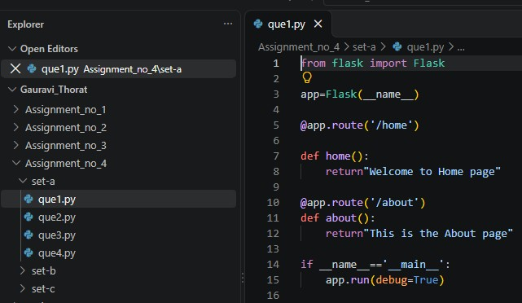
Output:
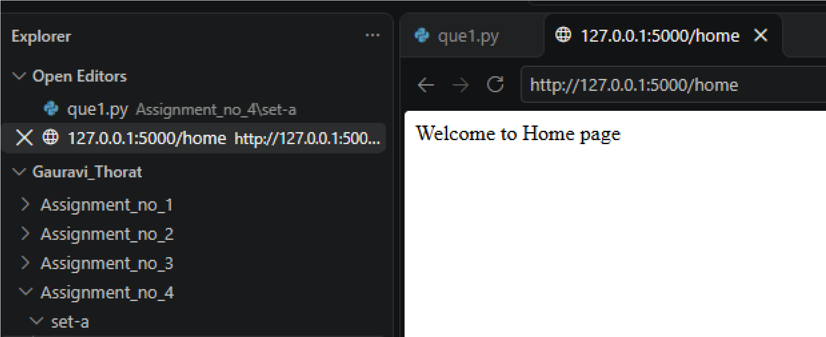
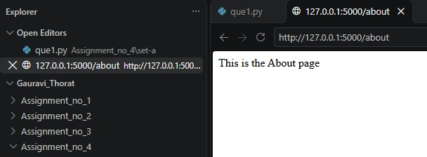
Q2. Create Contact and Services routes.
Ans:
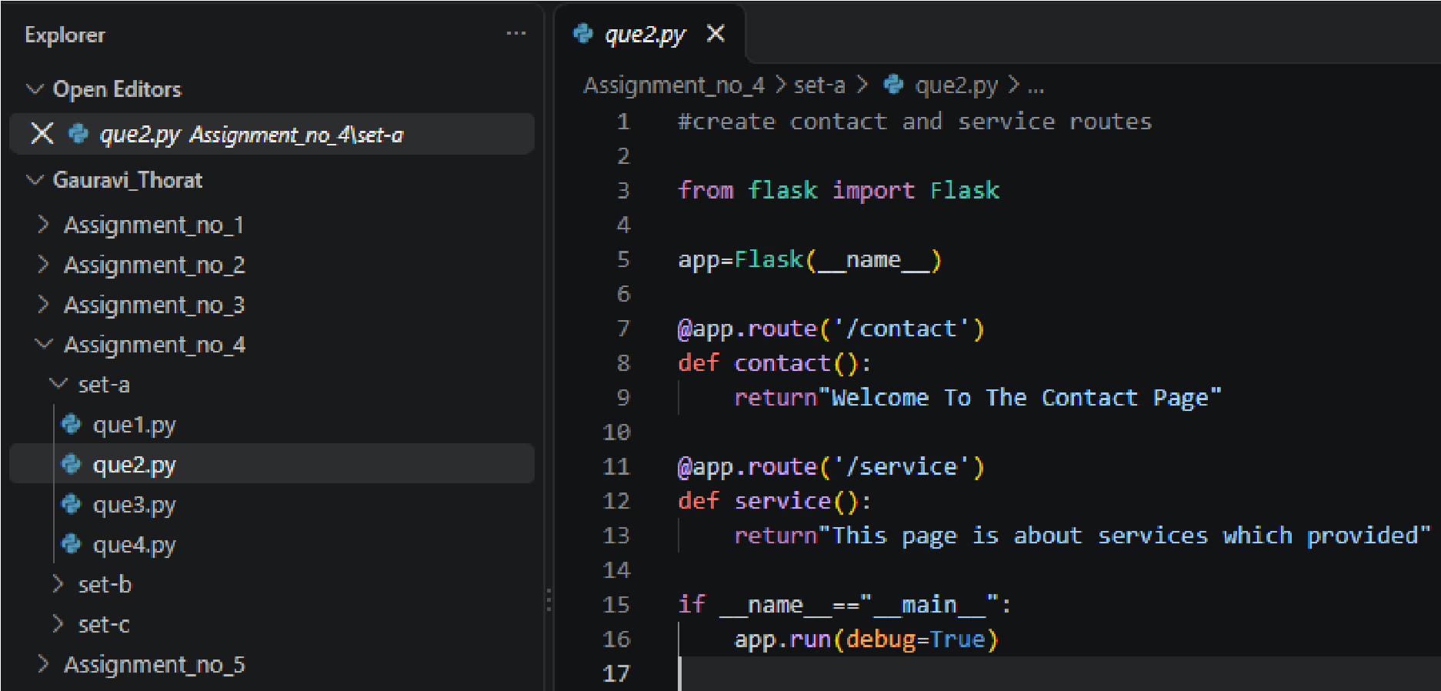
Output:
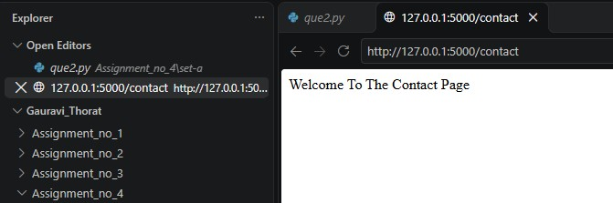
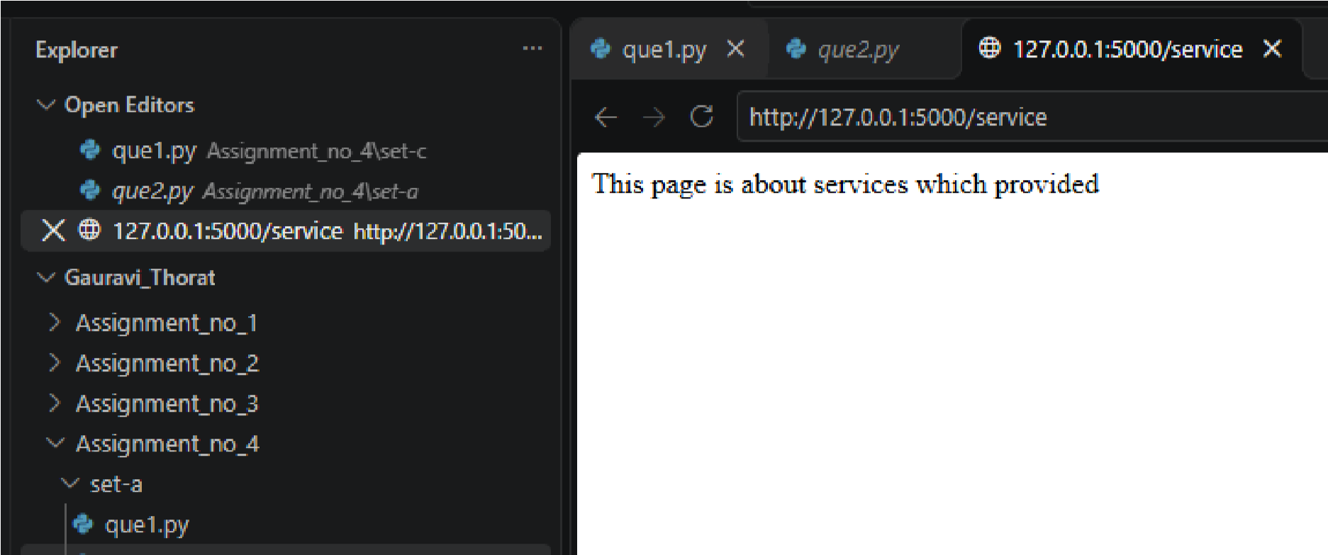

Set B:
Q1. Create dynamic route accepting student name.
Ans:
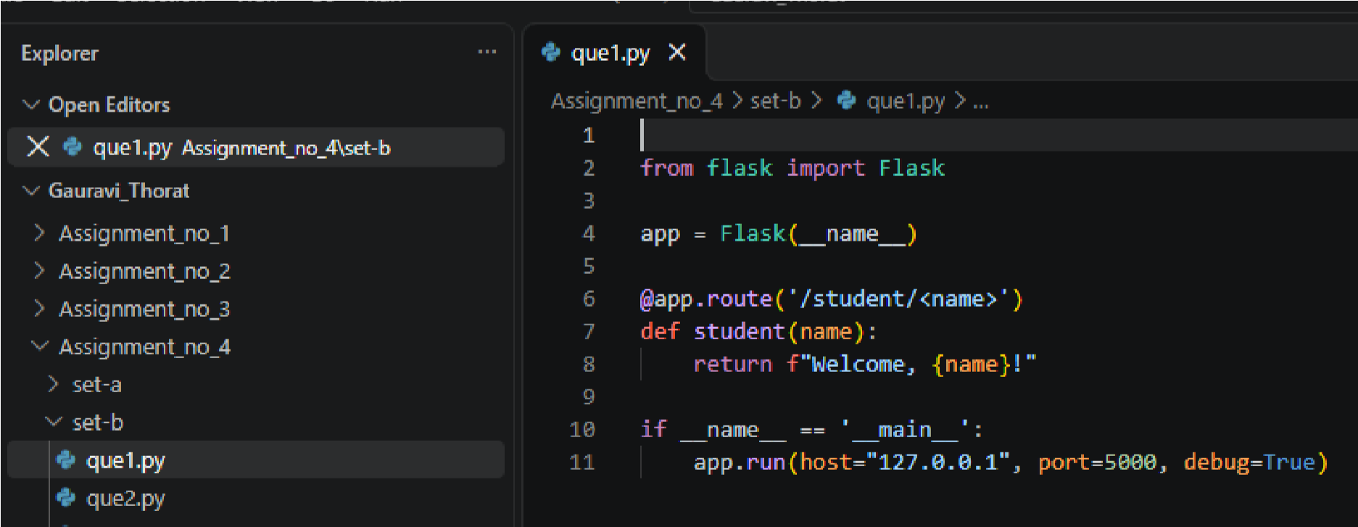
Output:
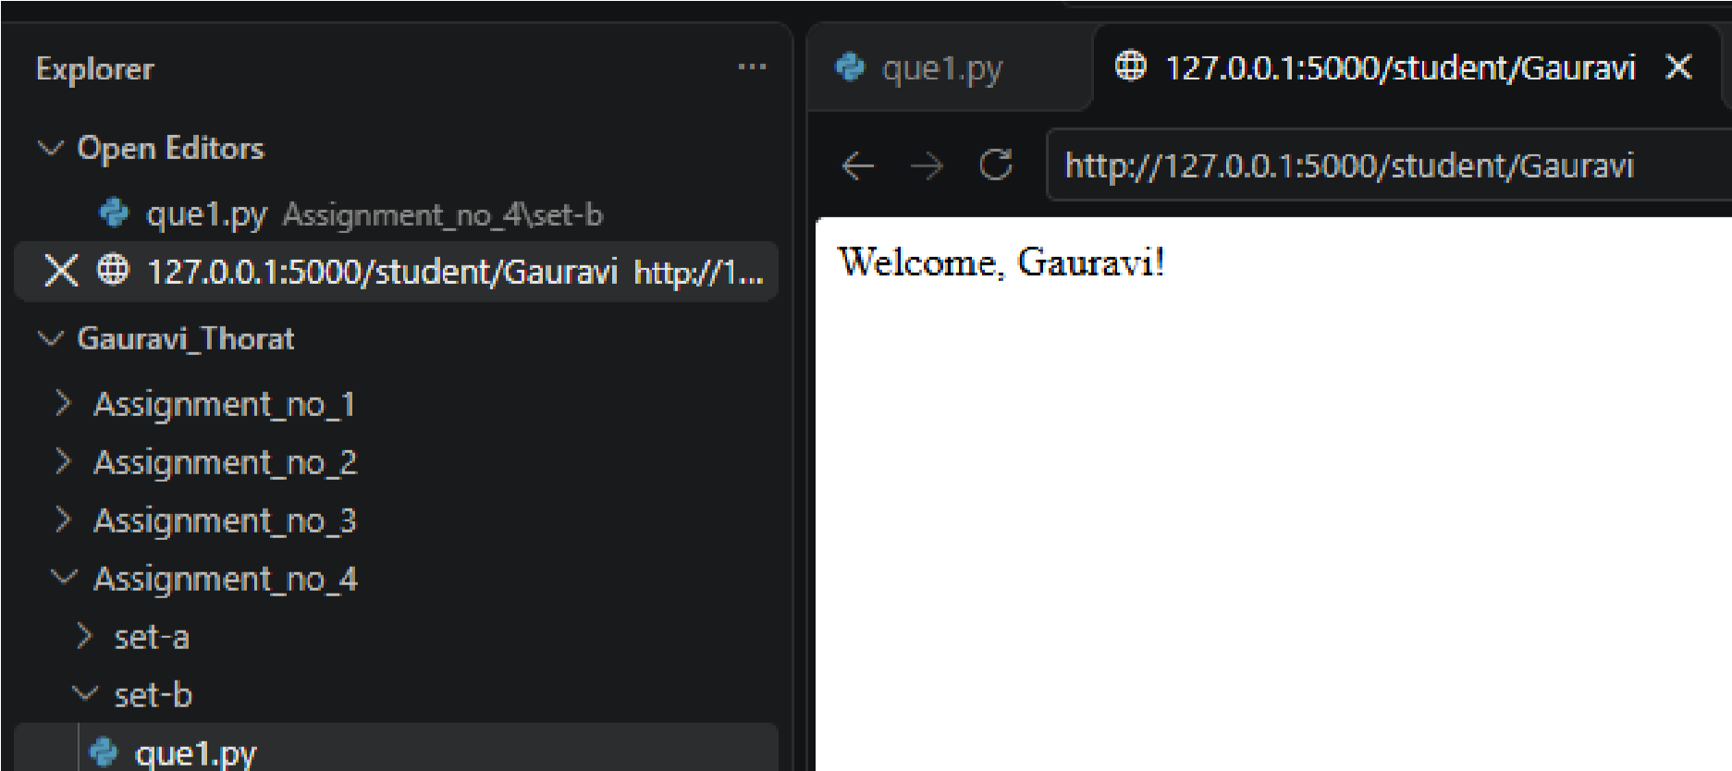

Q2. Create a dynamic route that accepts a number and displays its square Ans:
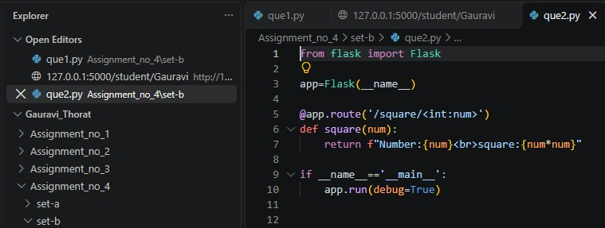
Output:
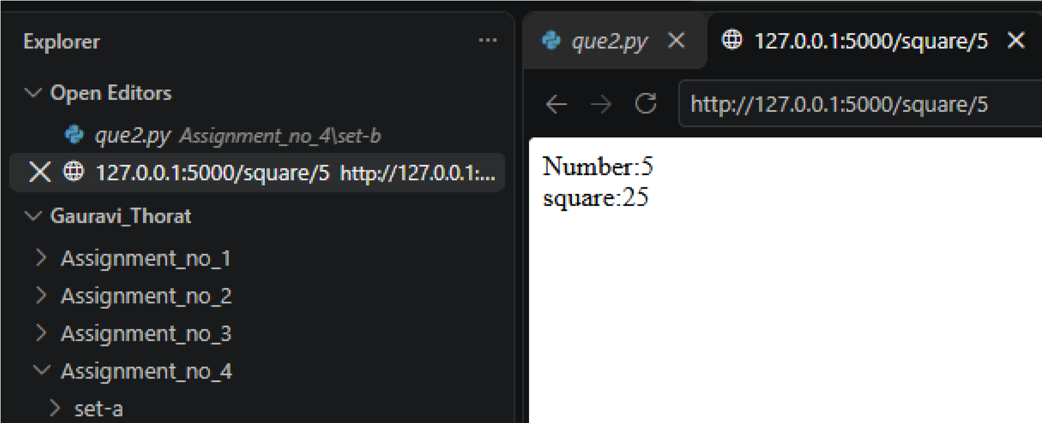

Set C :
Q1. Create dynamic route accepting product ID and displaying product details.

Ans:
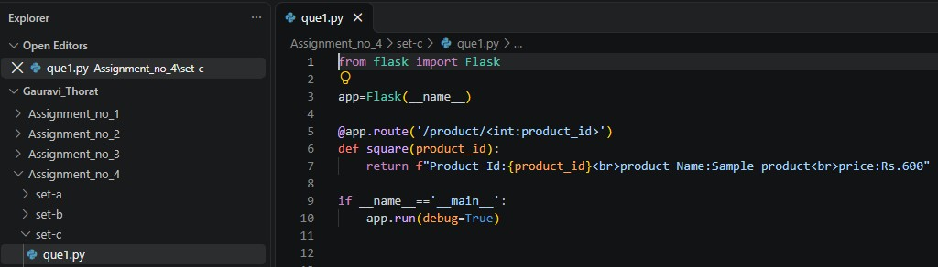
Output:
